**“TRAVEL AND TOURISM MANAGEMENT”**

**A Project Report**

**Submitted by:**

**Gaurav Dwivedi (190101115)**

**Mohammad Asad Akhlaq (190101181)**

**Prashant Kumar (190101220)**

**Shoaib Khan (190101283)**

in partial fulfilment for the award of the degree

of

**BACHELOR OF TECHNOLOGY**

**IN**

**COMPUTER SCIENCE AND ENGINEERING**

At



**SHARDA UNIVERSITY**

**Knowledge Park III, Greater Noida, Uttar Pradesh 201310**

**Table of Contents**

**Table of Contents:**

|  |  |  |
| --- | --- | --- |
| **Sr. No.** | **Particulars** | **Page No.** |
| 1. | Title Page | 1 |
| 2. | Table of Contents | 2 |
| 3. | Abstract | 5 |
| 4. | Acknowledgement | 6 |
| 5. | Gantt Chart | 7 |
| 6. | Problem Statement | 8 |
| 7. | Hardware Specifications | 9 |
| 8. | Software Specifications | 10 |
| 9. | Flowchart | 11 |
| 11. | Data Flow Diagram | 12 |
| 12. | Objective and Introduction | 13 |
| 13 | Theory | 14 |
| 14 | Algorithm | 15 |
| 15 | Results and Outputs | 16 |
| 16 | Conclusions and Credits | 17 |
| 17 | References | 18 |

**TRAVEL AND TOURISM MANAGEMENT**

**Made By:**

**Gaurav Dwivedi**

**Shoaib Khan**

**Mohammad Asad Akhlaq**

**Prashant Kumar**

**DECLARATION**

I the undersigned solemnly declare that the project report is based on my own work carried out during the course of our study under the supervision of Mr. Sushant Jhingran.

I. The work contained in the report is original and has been done by me under the general supervision of my supervisor.

II. The work has not been submitted to any other Institution for any other degree/diploma/certificate in this university or the any other University of India or abroad.

III. We have followed the guidelines provided by the university in writing the report.

IV. Whenever we have used materials (data, theoretical analysis, and text) from other sources, we have given due credit to them in the text of the report and giving their details in the references

**ABSTRACT**

The main aim of this project is Developing a WEB APPLICATION for Travel and Tourism Management. Basically, Tourism is travel for pleasure or business, also the theory and practice of touring, the business of attracting, accommodating, and entertaining tourists, and the business of operating tours. Our Travel and Tourism is Domestic i.e. Taking Holidays and Trips in own country.

You can travel via Flight or via train and as per your Destination our highly programmed System will present you our best packages. Our system provides customer's need and give them satisfaction. We Integrate a map facility so our customers don't have to reach other application for navigation like Google Map. We also have blogging facility where all our previous customers will share their experience and providing us some wonderful feedbacks and some suggestions. We mainly focus on the customer's need and satisfaction by providing them everything perfect.

**ACKNOWLEDGMENT**

I would like to express my special thanks of gratitude to my Mentor Mr. Sushant Jhingran as well as our Head Of Department Dr. Nitin Rakesh who gave me the golden opportunity to do this wonderful project on the topic developing a WEB APPLICATION for Travel and Tourism Management, which also helped me in doing a lot of research and I came to know about so many new things as it is my first project and I am really thankful to them. Secondly, I would also like to thank my parents and friends who helped me a lot in finalizing this project within the limited time frame and submitting it as soon as possible.

**GANTT CHART**

|  |  |  |  |  |  |
| --- | --- | --- | --- | --- | --- |
| Activities | July | August | September | October | November |
| Literature Survey | Study about the travel management | Factors Affecting travel management | How online travel management work | Rise of online travel & tourism | Future in travel &tourism |
| System Proposal | Planning the production of project | How to make a clean user interface | How to make a good customer servic | Traditional System travel & tourism | What are the steps to protect payment and privacy |
| Coding | Studying | Studying | Making Frontend | Designing Database & making the Backend | Submission |

**Problem Statement**

Tourism is travel for pleasure or business, also the theory and practice of touring, the business of attracting, accommodating, and entertaining tourists, and the business of operating tours. You can travel via Flight or via train and as per your Destination our highly programmed System will show you are best packages. The problem basically here is that the amount of travel management available on the internet is same everywhere and we need to provide those services which make us unique from the rest and more useful than the usual one so, we provide the user a experience which is more user friendly and protected.

We Integrate a map facility so our customers don't have to reach other application for navigation like Google Map. We also have blogging facility where all our previous customers will share their experience and providing us some wonderful feedbacks and some suggestions.

**Hardware Specification**

* **For Development, Hardware’s used are:**

1.      Intel Core i5(minimum 9th Gen)

2.      40GB hard disk

3.      4GB RAM

* **For Deployment, Hardware’s used are:**

**Minimum**

1.      Intel core i3 or better processor

2.      10 GB hard disk

3.      2 GB RAM

**4.**10-100 MBPS of Network card

**Recommended**

1.      Intel core i5 or better

2.      40GB hard disk

3.      4GB RAM

**4.**100-512 MBPS of network card

**Software Requirement**

1. Html: To give a structure to our website.
2. Css: For Designing of the website.
3. Bootstrap: To design the frontend.
4. Java Script: To automate within the frontend.
5. Php: To create and connect backend.
6. Database: PhpMyAdmin

IDE’s:

1. **Visual Studio Code:** Visual Studio Code is a free source-code editor made by Microsoft for Windows, Linux and macOS. Features include support for debugging, syntax highlighting, intelligent code completion, snippets, code refactoring, and embedded Git
2. **Sublime Text:** Sublime Text is a shareware cross-platform source code editor with a Python application programming interface. It natively supports many programming languages and markup languages
3. **Xampp (php):** XAMPP is a [free and open-source](https://en.wikipedia.org/wiki/Free_and_open-source) [cross-platform](https://en.wikipedia.org/wiki/Cross-platform) [web server](https://en.wikipedia.org/wiki/Web_server) [solution stack](https://en.wikipedia.org/wiki/Solution_stack) package developed by Apache friends, consisting mainly of the [Apache HTTP Server](https://en.wikipedia.org/wiki/Apache_HTTP_Server), [MariaDB](https://en.wikipedia.org/wiki/MariaDB) [database](https://en.wikipedia.org/wiki/Database), [interpreters](https://en.wikipedia.org/wiki/Interpreter_(computing)) for scripts written in the [PHP](https://en.wikipedia.org/wiki/PHP) and [Perl](https://en.wikipedia.org/wiki/Perl) [programming languages](https://en.wikipedia.org/wiki/Programming_language).

**Flow-Chart**

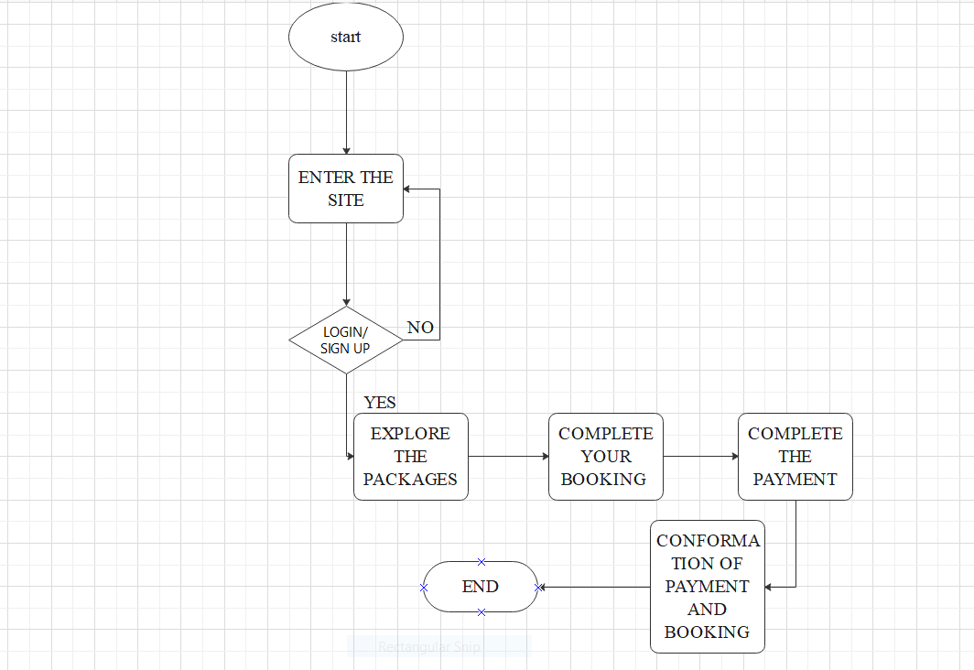

**DATA FLOW DIAGRAM**

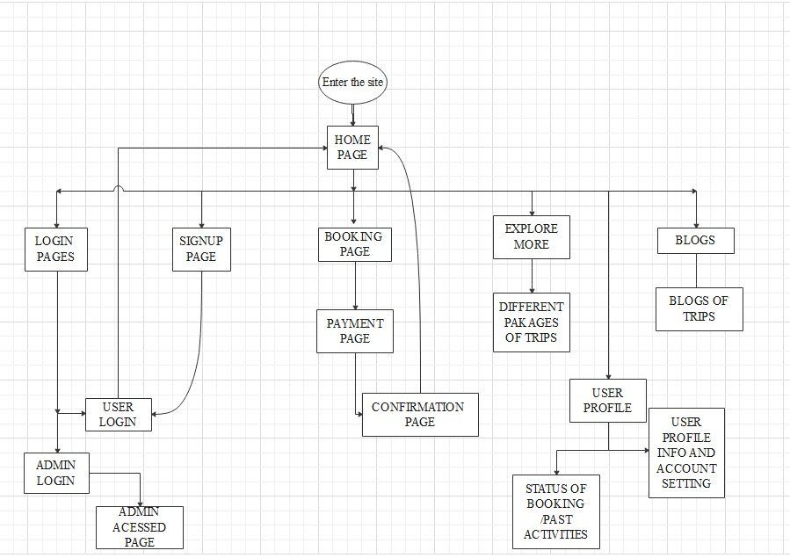

**OBJECTIVE:**

The Objective is to create a travel & tourism management system which is safe and protect privacy to plan consumers tours, to provide a best service to the consumers.

**INTRODUCTION:**

Travel and tourism management system is used to book a tour from anywhere in INDIA by a single dynamic website, which will help the user to know all the places and tour details within a single website. The admin can add packages to the website via sources and the Hotels by create a tour page. The user can see the confirmation in their my booking page. It is an easiest platform for all the travellers which can be easily booked and know the all details. Tour Management system is a dynamic website for tourism business. It is dynamic and responsive web design. It is also called travel technology solution for agencies & tour operation. Nearly Everyone goes on a vacation for this ‘a Tourism management system’ would play a vital role in planning the perfect trip. The tourism management system allows the user of the system access all the details such as location, events, etc. The main purpose is to help tourism companies to manage customer and hotels etc. The system can also be used for both professional and business trips

**Theory:**

The objective of the Travel and Tourism Management System project is to develop a system that automates the processes and activities of a travel and the purpose is to design a system using which one can perform all operations related to traveling. Tourism involves the activities of people travelling and staying in a place away from their home environment for leisure, business or other purposes. It involves the management of multitude of activities such as studying tour destination, planning the tour, making travel arrangements and providing accommodation. It also involves marketing efforts to attract tourists to travel to particular destinations.Travelling is going from the place of residence or work to another distant or a neighbouring place by any means of transport. Routine commutation can be termed as travelling. In our website, we have used basic Html to implement all the necessary functions in all the webpages & have used Css to modify as well as beautify the all the important components in our website. We have then used PhpMyAdmin to create the database using Sql at its base as well as connect the database to the Frontend.

**ALGORITHM:**

**Step 1**: Import The necessary dependency

**Step 2:** Using html construct the structure of the website

**Step 3:** Use CSS for designing the website

**Step 4:** Create the database for the project in Mysql

**Step 5:** Using XAMPP and php make backend and connect it with

Frontend and host the website on localhost

**Step 6:** Run the travel &tourism management website

**Step 7:** End

**Results and Outputs:**

We have completed our project with very minimal error, and we have got a very user friendly Travel & Tourism management web service.

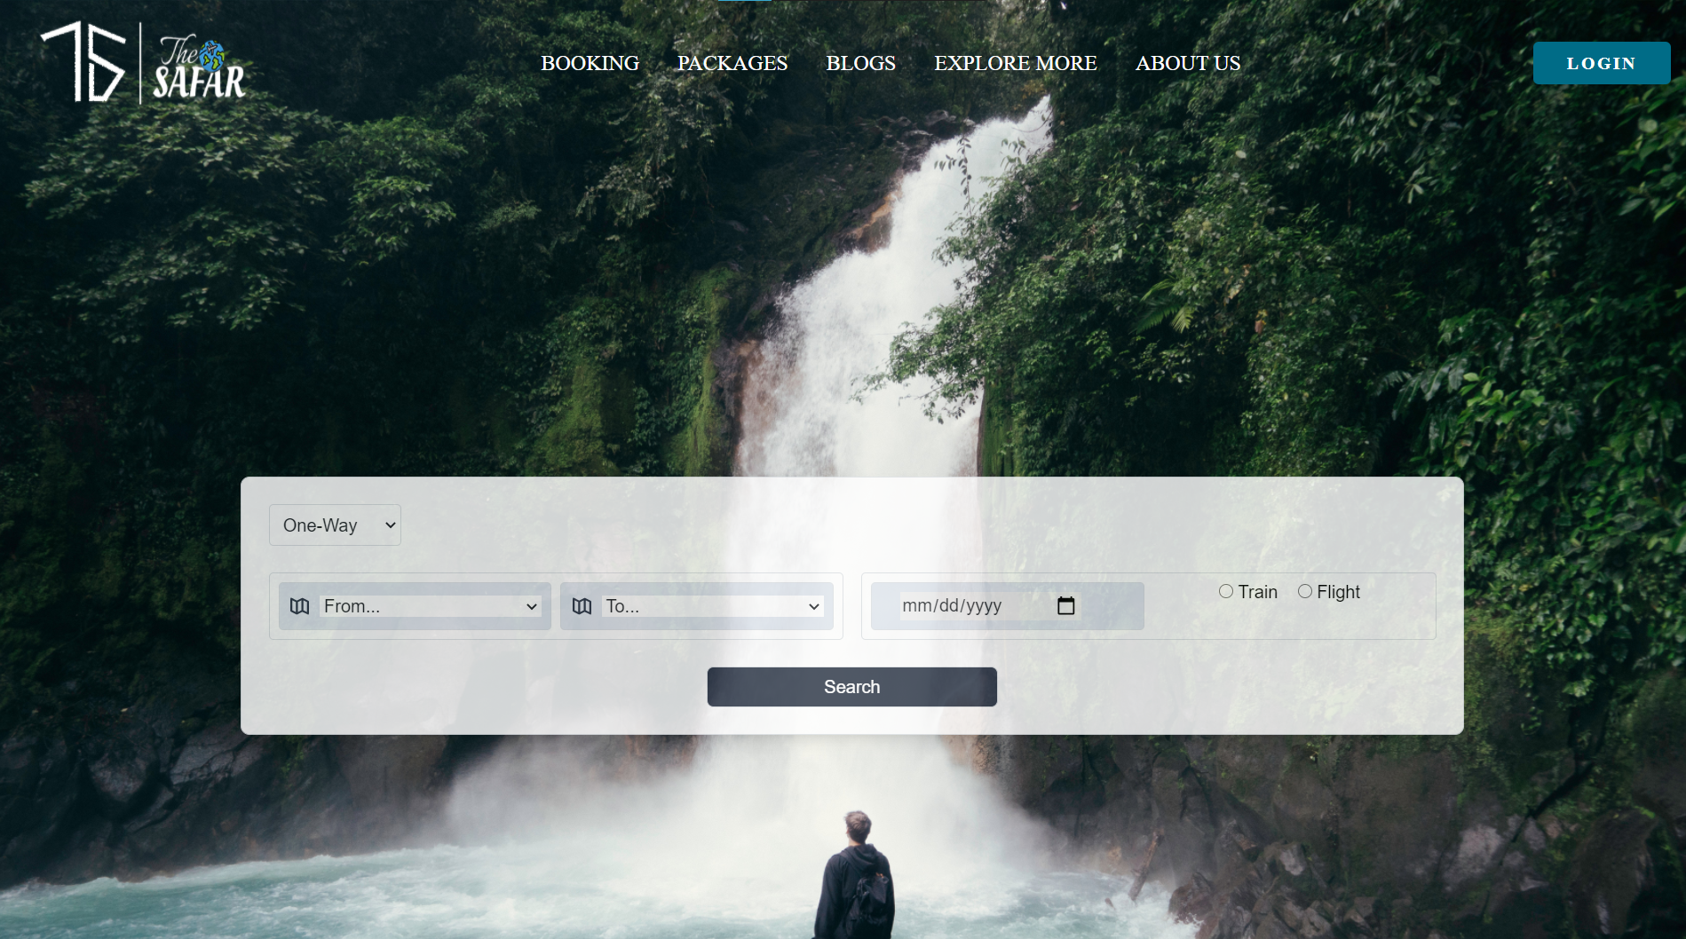

**Video link for our website –**

https://drive.google.com/file/d/1eKvDfhCBJSYfhgtRY802wQl26cZ_431c/view?usp=sharing

**CONCLUSIONS:**

At the end of this Travel and Tourism management project using HTML, CSS, PHP we understood how travel management works based online. We have learnt many new & advanced things during the process of making this project such about handling frontend program, we learnt how to manage backend and creating database and connecting it to the frontend is also one of the things we learned as a beginner, which we didn’t know much about and it was a great pleasure to do this project and learn and explore new things and we even promise ourselves to keep us motivated to do such project in the coming future.

**REFRENCES**

1. www.google.com
2. https://getbootstrap.com/docs/4.5/getting-started/introduction/
3. https://www.w3schools.com/bootstrap4/bootstrap_containers.asphttps://www.quandl.com/tools/api
4. https://tailwindcss.com/components
5. https://www.geeksforgeeks.org/html-tutorials/
6. [www.youtube.com](http://www.youtube.com/)
7. https://www.w3schools.com/js/DEFAULT.asp